Parent Engagement Suite

Platform Commons

Prepared by Satyam Gambhir

Version 0.1

Nov 01, 2021

# Executive Summary

Studies of successful schools indicate that a high rate of [parent involvement](https://eric.ed.gov/?id=ED513862) is a major factor in their success. Parents have immense potential to transform schools and to bring systemic change.

Saajha aspires to build a network of 10 million parents that would serve as a community learning platform and a drive that transforms the Indian education system. For this to happen, we need to design systems that steer & nudge the stakeholders appropriately. And design frameworks that organize the community for the community, digitally.

This document defines how a peer-to-peer, parents’ community could be formed, sustained and scaled with little to no external support. And could be governed digitally with levers provided to state governments.

# Digital Assets

There are three key assets that help achieve the objective

1. Call Center Support App
2. Admin & Governance System
3. Parents’ Community

And three key channels for engaging parents

1. Phone Conversation
2. Whatsapp Chats
3. Self Manage Parent’s Community

## Application Landscape

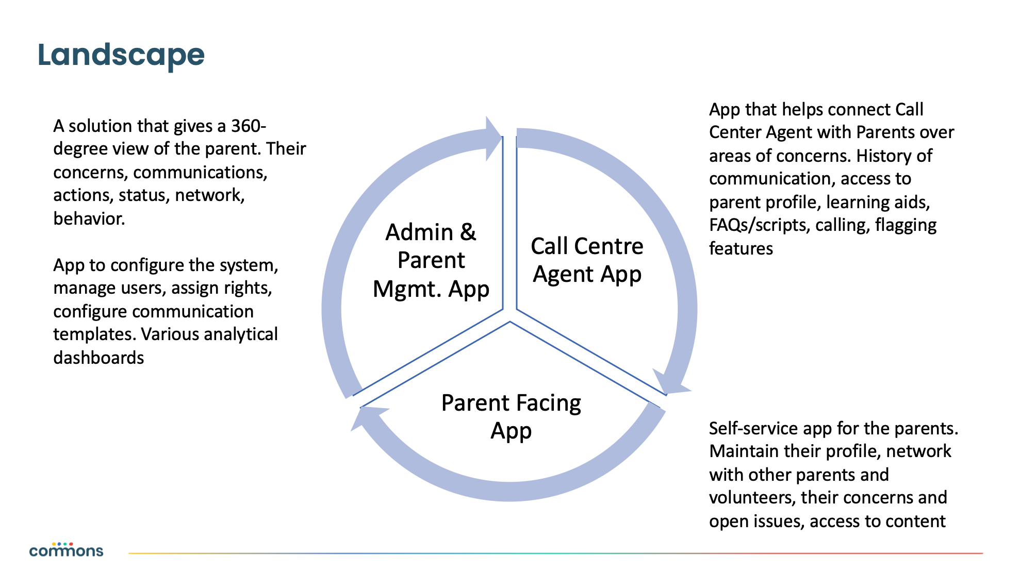

## Key Functions of Digital Assets

### Call Center Agent App

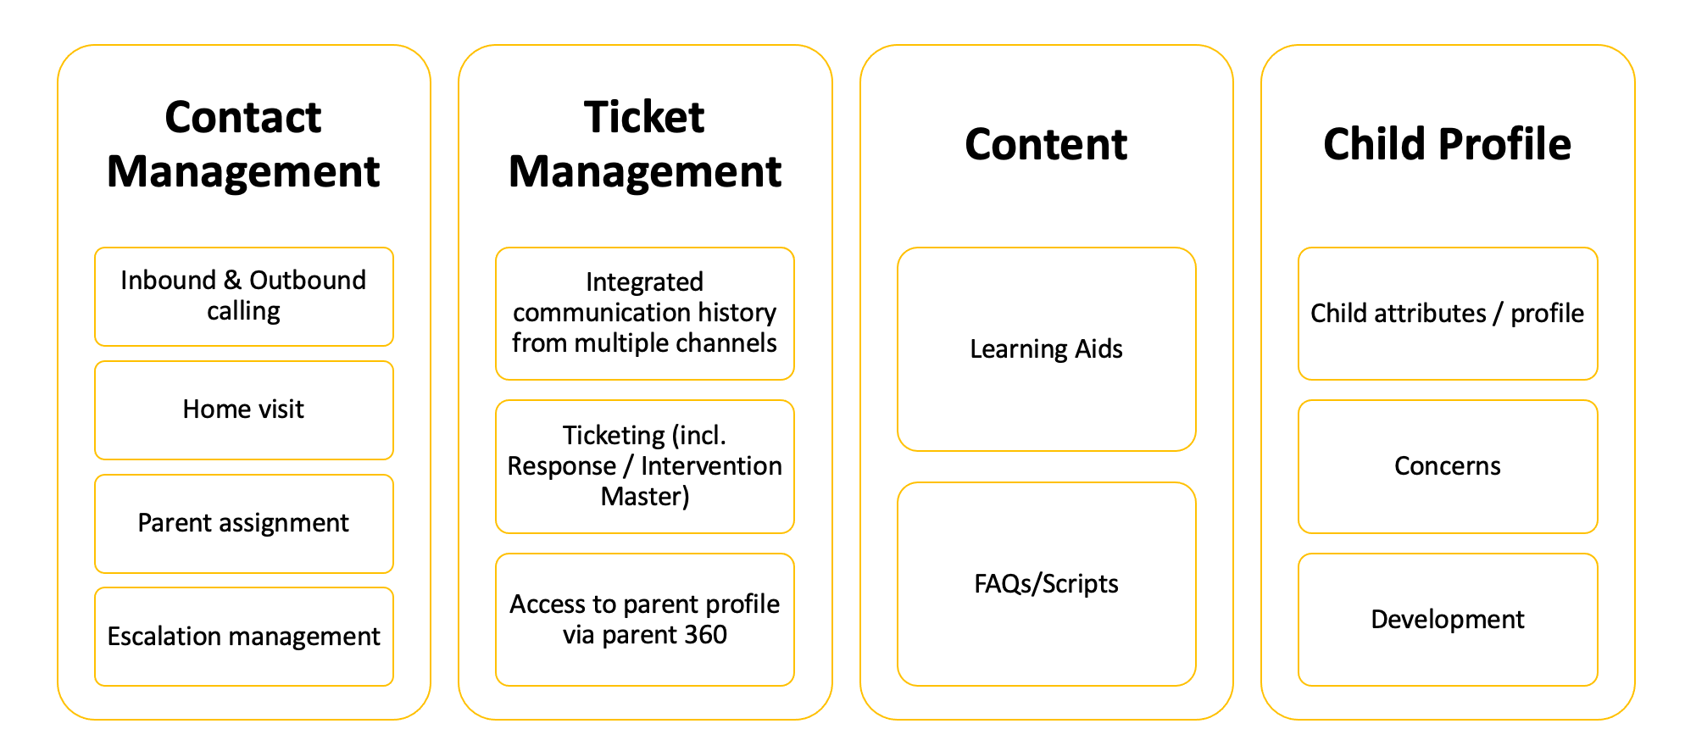

| **Requirement Document** | <https://docs.google.com/document/d/1MEzEgHs-m_pO2Ug4kkRgVMolnLoreK_J/> |
| --- | --- |
| **Screen Design** | <https://xd.adobe.com/view/24355ab7-55f1-4cfb-9b2b-bbb8a049a4ff-7166/> |

### Admin App

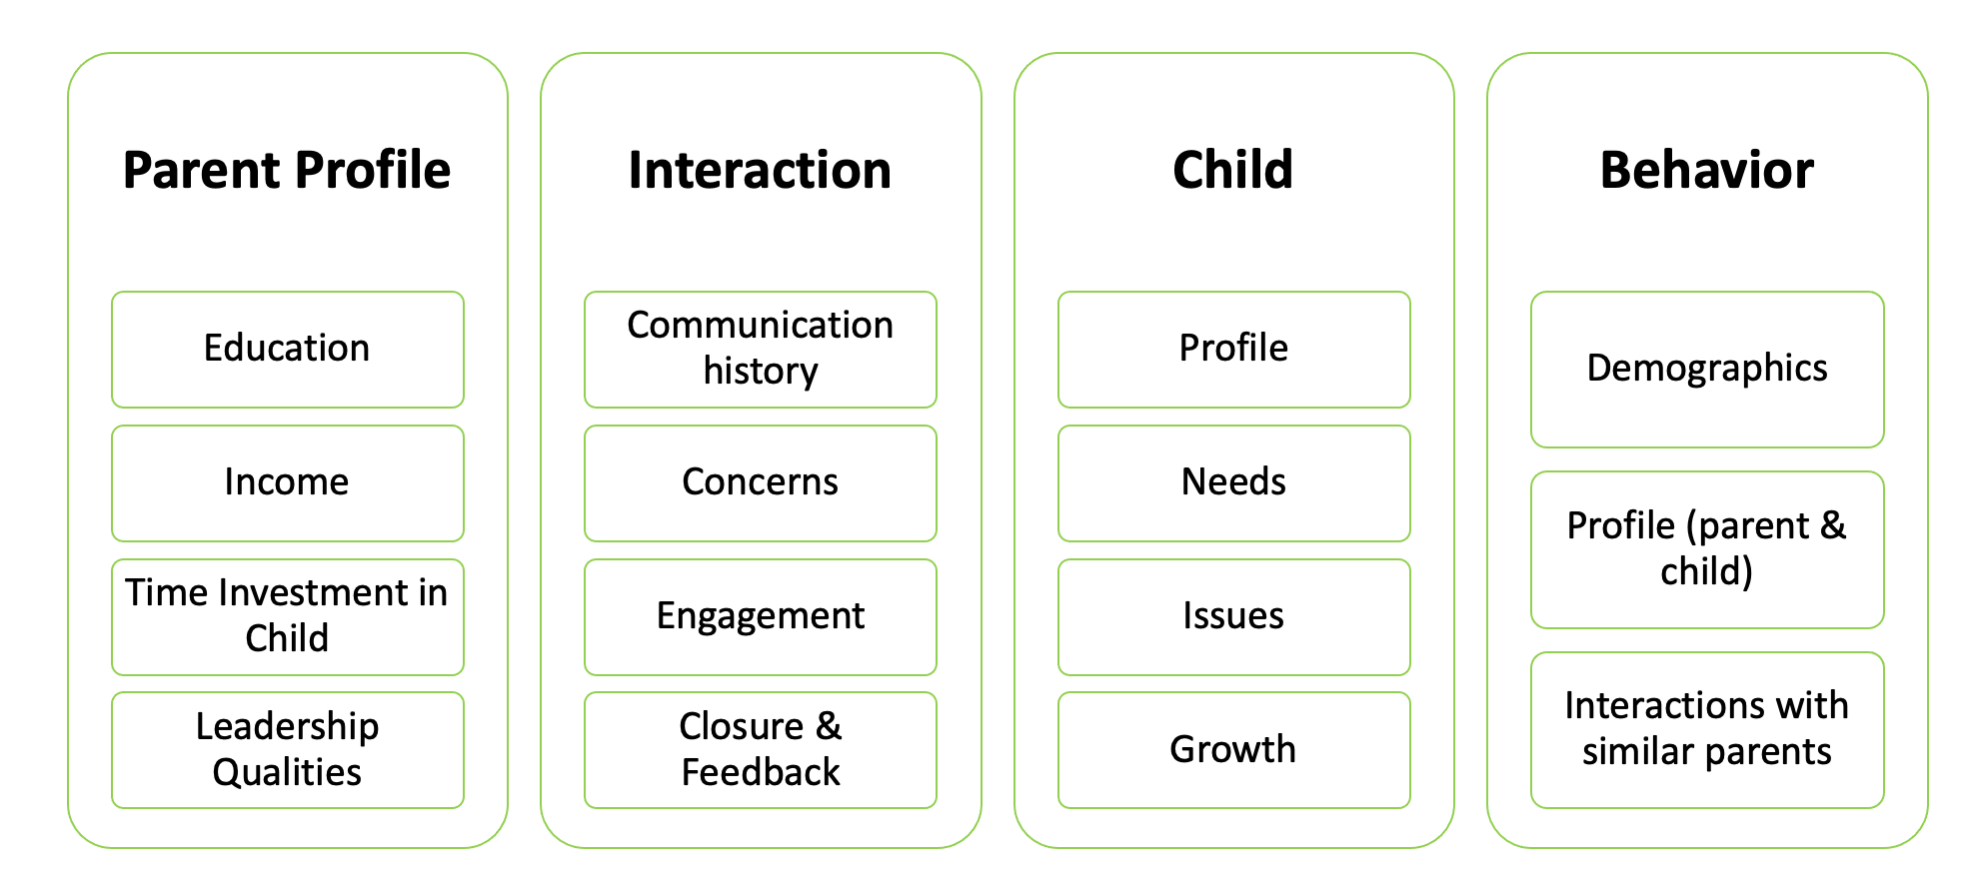

| **Requirement Document** | <https://docs.google.com/document/d/1BNdakPQWVoov3W01kWat0dQUId1VYQaWUL19tFx3gP8> |
| --- | --- |
| **Screen Design** | <https://xd.adobe.com/view/c9bf42d5-de79-4374-bc18-51bfa4c1645b-9cec/> |

### 

### Parent Engagement App

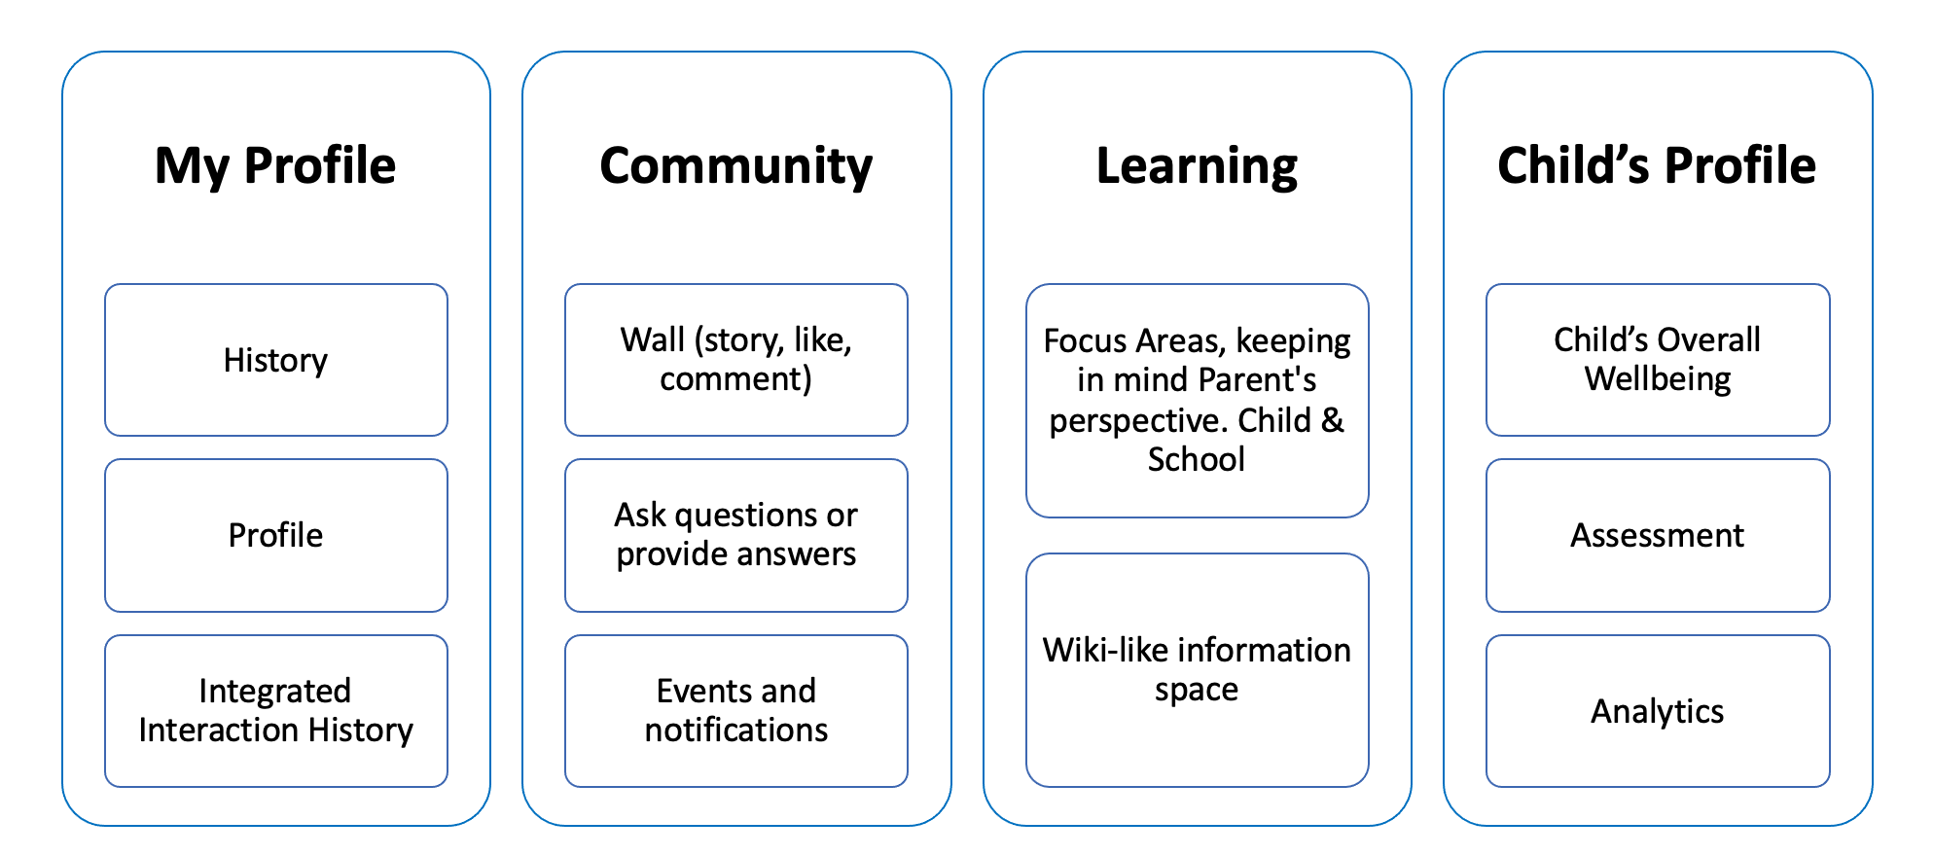

| **Requirement Document** | <https://docs.google.com/document/d/1mWiPFcWV-pkZM_fFUXRBoI062Qng4Sm1_og5T7eh2pA> |
| --- | --- |
| **Screen Design** | <https://xd.adobe.com/view/2bebd3fe-b4b8-4d3c-ad5e-569b0efc0567-7eb8/> |

# **Technology Overview**

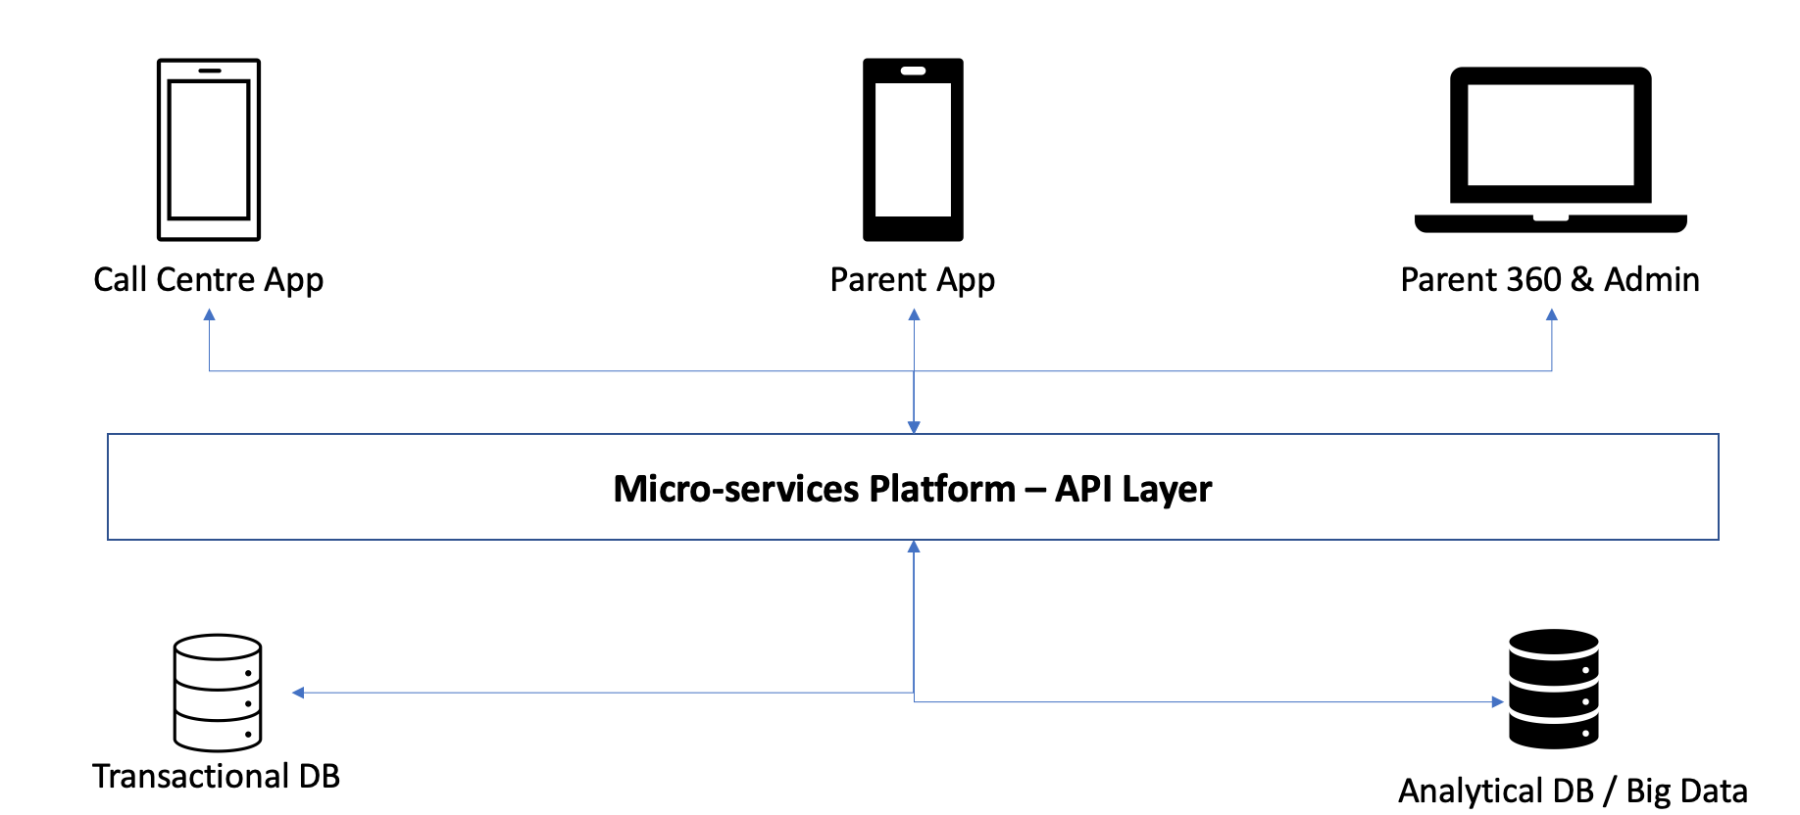

# **Proposed Team Size**

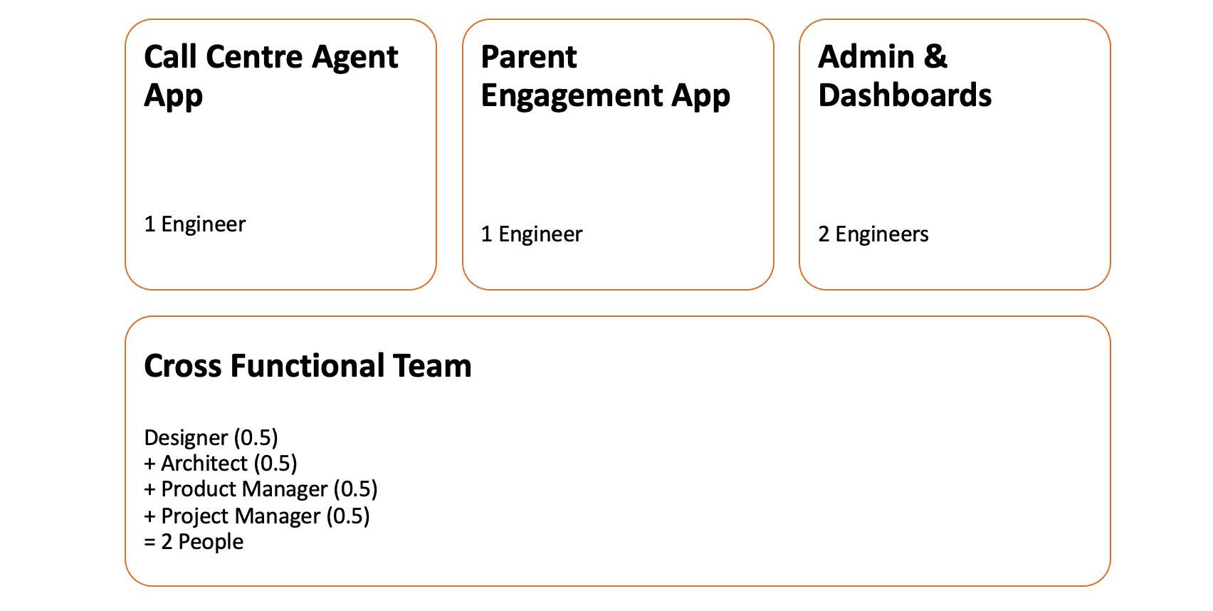

# **High Level Project Plan**

|  | **Call Center Agent** | **Admin & Other Functions** | **Parents Website** |
| --- | --- | --- | --- |
| Q1 | * Service Mapping * New Services Development * Workspace Management * Registration | * Service Mapping * New Services Dev. * Workspace Management * Parent Management System |  |
| Q2 | * Parent Management * Roaster Mgmt. * Call Routing (VOIP Integration) | * Whatsapp Integration * CCA Management * Roaster Algorithm |  |
| Q3 | * FAQ & Script Management * LMS | LMS   * Script Management * Role Based Access Control | * Service Mapping * New Services Development * Registration & Onboarding |
| Q4 | * Interaction History * Home Visit | * Children Profile & Analysis * Reports and Analytics | * Profile * LMS |
| Q5 | * Participation in Parents forums | * App Improvements | * Children Profile & Assessments * Community Interaction / Forums |
| Q6 | * App Improvements | * App Improvements | * Access Interaction History |
| Q7 | * App Improvements | * App Improvements | * Badges & Gamification |
| Q8 | * App Improvements | * App Improvements | * App Improvements |